Welcome page corrections
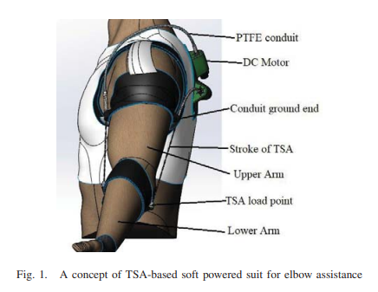
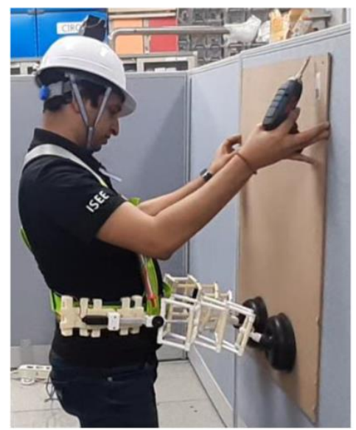
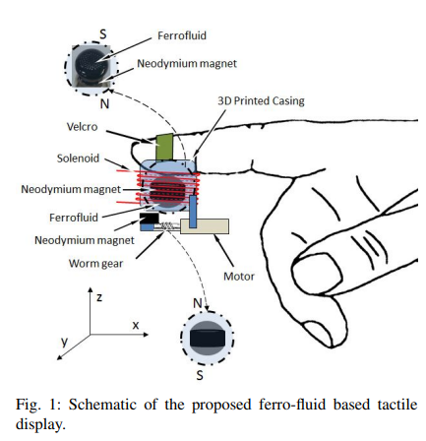

Remove this photos and below one
This photos if there is pic quality issue then let know I’ll another one


Remove this section


Here remove bird picture and put IITJ logo



REMOVE THIS

Research Area Page Update
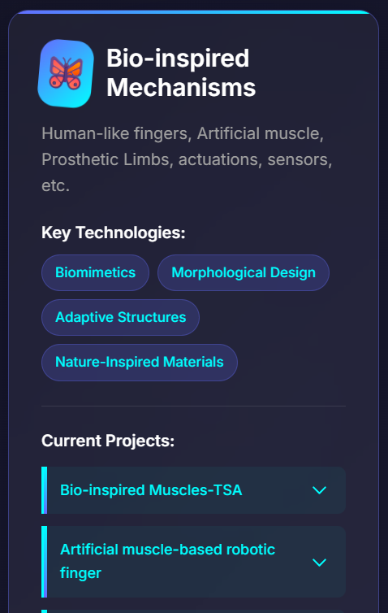
Incert intro that I gave in another doc files/link
Remove this

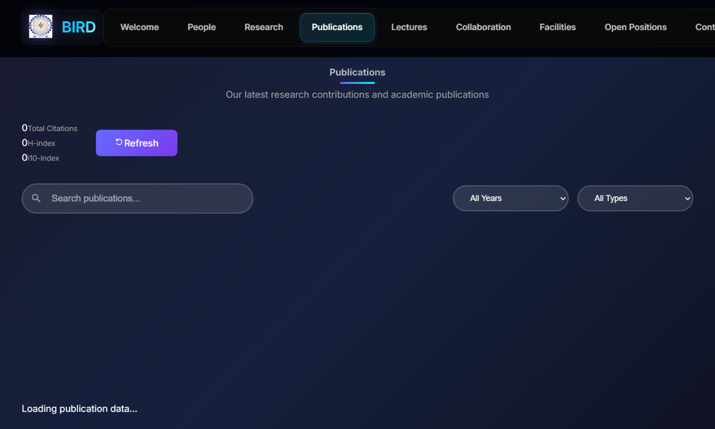
Contact
Not working have a look on lt
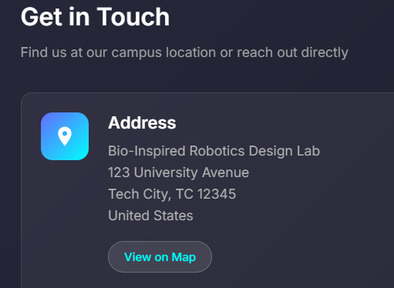
Write IIT jodhpur
or our SAIDE, dept address.

Facility page
Make it the same as you made the collaboration page .
Just include while clicking on any facility image, it shows the image and side-by-side information as given in the PDF.
if you have any doubt, please call me

